A Green Crowd Funding Project that promotes health & wellbeing in Tonga

Help Tongans Build a Cycling Culture and Industry. Your help will make a difference to individuals and a country.
You can be part of the development of a green project that actually helps to improve the health and wellbeing of the Tongan people in a direct way! Tongatapu is a small flat island with limited road network and all cars must be imported. Why not import bicycles?
Here is where the details of the project can be found: https://chuffed.org/project/cycling-in-tonga

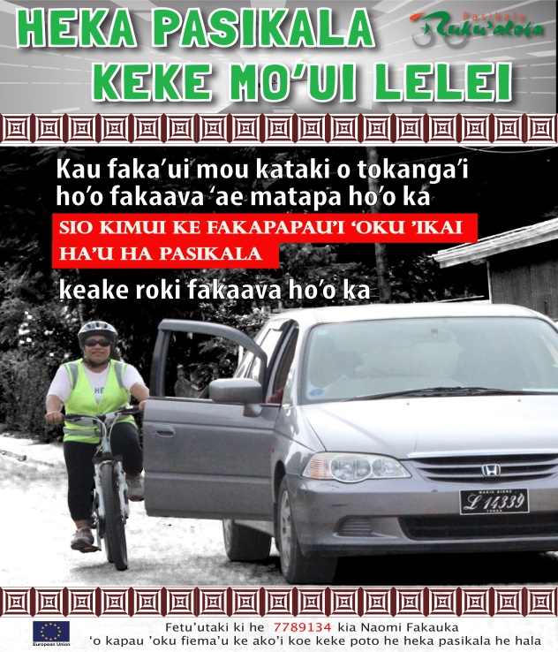

Here is a country that needs support to set up a new industry. This industry will encourage people to be more physically active and thereby reducing the likelihood of developing diabetes.
Rotary Redcliffe in Queensland have already sourced, serviced and sent a container of bicycles to Tonga. This article describes their involvement: http://rotaryredcliffecity.org/100-bikes-start-320... Naomi who works for the Red Cross in Tonga is seeking to build on this excellent beginning. She is seeking funds to support the importing of a second container of bicycles. Naomi also has a Certificate 4 in training and assessment, so she is well placed to train local Tongan people in bike maintenance etc. Brett Richardson is bike enthusiast in Queensland and has a strong record in training, supplying and supporting the Tongans as a practical level.

But there’s a problem
Importing to Tonga is costly; the distance is great. Also establishing a bicycle culture needs support and embedding into the Tongan community. While this project has practical support from locals, it needs much needed funds to make this international development project succeed.
You can join us.
We are seeking to raise $10000. $5000 is the price for sending a container load of bicycles to Tonga. The remaining funds will be used to support the training of locals, setting up bicycle events and to establish a retail outlet. The retail outlet will ensure the sustainability of the project. Rotary Fitzroy are taking the lead on fundraising.

And here’s some amazing perks for supporting us that you can’t live without
- You are eligible for a Tshirt supporting the Tongan Bike Club
- You will be eligible to participate in the bicycle events that will be established, the first entry will be free.
- If groups and organisations contribute, you could become a sponsor with acknowledgements in publications.
All contributions will be acknowledged wherever possible.

For more information contact:
Denise Charman or The Rotary Club of Fitzroy
denise.charman393@gmail.com or 0422 309 494

